Name_________________________________________________________________Date____________________________
Integrated Algebra Bell Work

Topic: Substitution Method

Directions: Solve the following system of equations using the SUBSTITUTION METHOD.

1. | 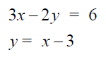 | 2. | 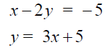

Name_________________________________________________________________Date____________________________
Integrated Algebra Bell Work

Topic: Substitution Method

Directions: Solve the following system of equations using the SUBSTITUTION METHOD.

1. |  | 2.

